Livestock Production
Swine
Ear Notching

To keep the appropriate records, pig breeders must notch each individual pig born on their farm. There is an international system that has been put into places for pig breeders to follow. Below is an example of this system
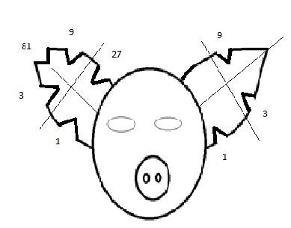
Individual
Number

Litter Number

If you will notice, the ear is broken into quarters. Each quarter represents a specific number. As well, each ear represents something specific; the pig’s left ear is its individual number and the right ear is the liter number.
On the pig’s right ear the numbers go from 3-81, this is because there can be several hundred sows on one farm with each sow how having 10-40 liters in their life time. Whereas, most sows will only have 8-15 pigs in one liter.
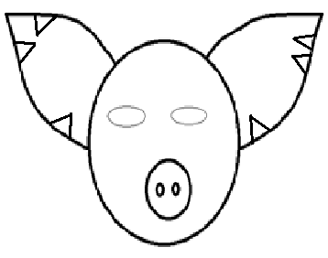
There will only be two marks in each quarter, then you will move to the next quarter for the higher number. Example: Two notches in the #1 quarter = 2 and the next possible number would be 3, the next numbered quarter of the ear. Look at the following examples of notched pigs ears.
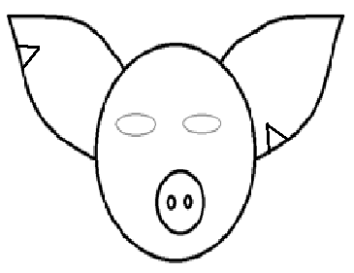
Pig 3-1 Pig 13-7

Livestock Production
Swine
Ear Notching

Directions: Using the given numbers, appropriately notch each of the individual pigs ears.

- 92-11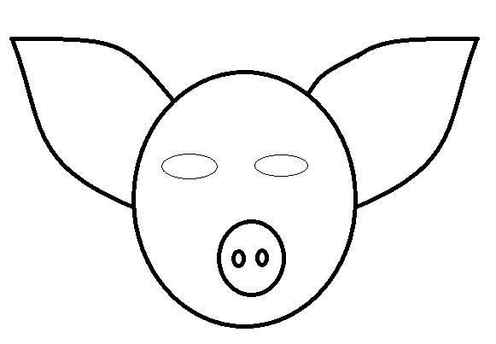
- 12-10
- 17-1
- 62-7
- 13-11
- 22-4
- 101-3
- 50-9
- 3-5
- 19-13

